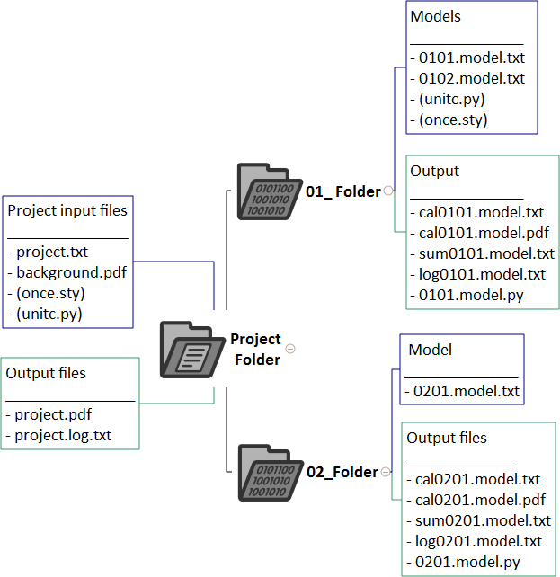
Project Folder
- 01_ Folder
  - Models ______________ - 0101.model.txt - 0102.model.txt - (unitc.py) - (once.sty)
  - Output ______________ - cal0101.model.txt - cal0101.model.pdf - sum0101.model.txt - log0101.model.txt - 0101.model.py
- 02_Folder
  - Model ______________ - 0201.model.txt
  - Output files _____________ - cal0201.model.txt - cal0201.model.pdf - sum0201.model.txt - log0201.model.txt - 0201.model.py
- Output files ________________ - project.pdf - project.log.txt
- Project input files _______________ - project.txt - background.pdf - (once.sty) - (unitc.py)

